To do
- Complete organisation of thesis
- Write appendices
- Change figure text size to be readable. Also put X and Y on the indifference in figure 1c) (see page 5)
- Fix equation symbols for consistency

Wolfram notes:
- economic decision-making is not modern nor new (500 years), as all animals, including fruit flies, make economic decisions. I would define an economic decision as one that deals with reward ('value-based decision'), as opposed to pure, value-free, perceptual decisions.
- the equations for the St Persburg paradox are fine, but I would find a Bellman equation, including mention of its relationship to economic optimisation (utility maximisation) more relevant, as it is the basis for TD-RL.
- I don’t agree that C. elegans following a chemical gradient makes a perceptual decision. Yes, there is a sensory experience involved (chemical here) but so is the case for a choice between two fractals on a computer monitor. What C. elegans really wants is the best reward, or escaping something noxious, which is an economic decision, according to my definition above.

Notes to reviewers:

Thank you for reviewing
This chapter I’m fairly happy with as is. There are some obvious things to be completed (usually in red) but the main text is mostly complete.

Things I don’t really care about so don’t waste time looking too deeply:
- Equation symbols are a bit of a mess. I haven’t found a convention I like. Small job that can wait to the end. The equations and derivations should still make sense and if you spot any math errors would really like to fix those, but don’t worry too much
- Figure/equation numbers are a mess. I’ll go through at the end and get a standard and fix them, that’s fine. Figure size etc. can also be a bit off. I’m going to go back and look over all of them before submitting.
- Appendix 2 is very rough still and I haven’t figured out how to end it. Would still appreciate a reading but it’s a bit of an involved appendix which I’ll get the lab to really look at
- My writing style is annoying to lots of people and uses lots of footnotes and appendices. Unless it’s really really a problem, I’m probably not going to fix that in the interest of time
Things I do care about:
- Spelling etc. if you spot any mistakes
- Some of the intro might be a bit opaque to non-scientists/non-neuroscientists but I think at least the main body should make sense the whole way through. My examiners are from the neuro department but also the economics department so if it completely loses anyone theres a good chance it’ll lose one of them and I need to double check it

Thanks again

To situate the chapter:
The first thesis basically opens up the ideas I will be talking about in (kind of) general terms to economics and neuroscience. A little detail on dopamine perhaps but not too much. I don’t talk about methods etc. or auction theory at all because the entirety of chapter 2 goes into this and I wanted to keep it separate. You might not be exactly clear what the main experiments are after this chapter- it’s ok.

Motivation

It is plain to see that economic decision-making is a fundamental aspect of modern human existence. Even before sitting down at their desk, a commuter must integrate multiple decision variables to calculate which mode of transport to take, is bombarded with advertisement for consumer goods, and faces a choice of breakfast options that would be unimaginable even a millennium ago. The brain has the unenviable duty to gather required information, incorporate it into a common framework, and decide between alternatives for each of these tasks.

Over the last 500 years, economics has found success in explaining what people decide when they are deciding. Utility has emerged as the fundamental variable of interest which is maximised along economic choices. These subjective values present in any choice are generated internally to the individual faced with alternatives and must be elicited via careful study of behaviour. Over the past 50 years, auction theory has proved successful in developing mechanisms which incentivise participants to declare the utilities of offered goods on a single trial basis.

Theories of utility have proved successful both prescriptively, in setting axioms for how a hyper-rational decision maker should act, and descriptively when studying how and when humans break these ‘rules’ (Luce & von Winterfeldt, 1994). As impressive as the economics literature is, it cannot tell us how the brain manages to navigate these choices every single day of our lives.

More recently, neuroscience has identified the activity of dopaminergic cells in the midbrain as a putative substrate for utility. These neurons have been shown to encode and integrate multiple variables crucial to this function such as the magnitude, probability, and temporal delay of rewards. By combining these parameters into a common signal, dopaminergic neurons facilitate the direct comparison of and selection from choices that encompass a vast decision space. By reinforcing choices that maximise utility, these neurons serve a crucial role in balancing an organism’s motivations and disturbances to this system have been implicated in severe neuropsychiatric disorders such as Parkinson’s disease and schizophrenia.

Central to research into the function of midbrain dopaminergic neurons are electrophysiological recording methods which allow researchers to study the behaviour of these cells with unparalleled temporal and spatial resolution. Such recordings require direct access to nuclei nested deep within the brain and so are unsuitable for studies of human decision making. Instead, most cellular studies of economic decision-making have relied on rodent or non-human primate models, limiting the sophistication of the choice tasks that can be employed.

The motivation for this thesis is to overcome these limitations so that we might gain a greater understanding of the dopaminergic utility signal. We aim to investigate the activity of midbrain dopaminergic neurons in rhesus macaques trained on a task inspired by auction theory to provide a real time readout of utility while observing changes in neuronal activity.

Organisation of the Thesis

The remainder of this chapter is spent reviewing the fields of economics and neuroscience. We chronicle the development of theories of utility before examining the evidence that the brain, and especially the dopaminergic midbrain circuitry, encodes utility. We also discuss the experimental task paradigms that animal research into utility has employed.

In chapter 2, we compare these paradigms to a second-price auction developed by Becker et al., 1964 and explore the theory behind what makes these ‘Becker-DeGroot-Marshak’ (BDM) auctions appealing to behavioural economists. We conclude the chapter by looking at the growing neuroscientific literature of human economic decision-making using auction tasks and why we consider the BDM an appealing choice for investigating the function of neuronal circuits of reward.

In chapter 3 we detail a BDM auction task we developed and trained two rhesus macaques on. The behaviour of the primates on the task is explored and is compared to more traditional choice

Chapter 4 concerns the electrophysiological recording of midbrain dopaminergic cells from two trained rhesus macaques. It begins with the single-cell recording procedure and the confirmation of the dopaminergic nature of recording cells. We then analyse the dataset produced to

In the final results chapter we take our findings from

Finally, we conclude by discussing

Organisms as utility maximisers
The choice of all possible actions in the world is potentially infinite, yet each organism only has a limited amount of time, effort, and (in the case of humans) money they can expend. As such, a key function of the brain is to accumulate the evidence needed to whittle down choices and eventually decide on the single course of action that will benefit the organism most over the duration of its remaining lifespan. On the simplest level, organisms are compelled to travel or grow towards increasing gradients of the chemicals they require to survive and propagate their genes. In evolutionary biological terms, they maximise their ‘reproductive fitness’.
In C. elegans, the decision to move forwards or backwards is simply an integration of the evidence for or against a chemical in its vicinity (Tanimoto et al., 2017). Such decisions are perceptual in that they deal with some external, observable quantity in the outside world. Regardless of whether the worm makes the decision to move away (in the case of this study) from a noxious chemical, there exists a unidimensional scale of the decision variable (i.e. strength of concentration gradient) which behaviour can be regressed against.
Rhesus macaques and human participants in neuropsychological studies are able to produce similar perceptual decisions when presented with an array of randomly moving dots and the chance to win a reward (juice or money) if they can guess the correct aggregate direction (Shadlen & Newsome, 2001). A competent programmer can define exactly the coherence of the dots movement without having to know a single thing about the organism participating in the task.
In economic tasks, there is no such external dimension which dictates a correct choice between alternatives and the difficulty of that choice. Even in token economies developed by humans, people frequently make choices which do not maximise monetary value. For example, it is not uncommon for individuals to both seek risk and buy lottery tickets and avoid risk by paying insurance premiums, despite both having a negative expected value in units of currency (Friedman & Savage, 1948). Even for certain goods, it is plain to see that a cheeseburger has more benefit to a starving man than a piece of jewellery which may be many times its value. Instead of comparing items against cost, people instead factor the monetary cost into some utility function which they use to maximise their own internal subjective value for goods.
This tendency for individuals to seek actions that maximise a utility function, rather than value, was first described by Daniel Bernoulli in the 18th century as an answer to the St. Petersburg 'paradox' (Bernoulli, 1738). In this thought experiment, a player is offered the chance to buy into a lottery where a coin will be flipped $n$ times until it lands on heads. At that point, the player will be paid out $2^{n}$ dollars. The first five terms of the expected value ($EV$) of this game are equal to the chance of each outcome ($p(x_{n}$)) multiplied by the magnitude of that outcome ($x_{n}$), and are as follows:
Equation 1.1
$${EV}_{n}= p(x_{n})⋅x_{n}$$
$$EV = \sum_{n = 1}^{∞}{{\left(\frac{1}{2}\right)}^{n}⋅2^{n}}$$
$$EV = \left(\frac{1}{2}⋅2\right) + \left(\frac{1}{4}⋅4\right) + \left(\frac{1}{8}⋅8\right) + \left(\frac{1}{16}⋅16\right) + \left(\frac{1}{32}⋅32\right)... = 1 + 1 + 1 + 1 + 1 +....$$
For instance, if a player bought into the lottery for $10 and the coin landed on heads on the third flip, the player would win $8 and make a total loss of $2. However, as the summation term in equation 1.1 is infinitely long, the expected value of the lottery becomes infinite. That is, a ‘rational’ player should be willing to spend an infinite amount to play this game. Clearly this defies common sense; it seems clear to an observer that any person who gambled away their life savings buying into the game would likely end up disappointed. In reality, Bernoulli remarks, ‘any fairly reasonable man would sell his chance, with great pleasure, for twenty ducats’. Instead of judging the expected value of the lottery, he supposed that ‘people with common sense evaluate money in proportion to the utility they can obtain from it’.
This formulation of utility stipulates that the subjective value of the possible winnings is different from person to person. For instance, though a $10 bill lying on the sidewalk is a net profit for any person who comes across it, it is likely to elicit much greater joy in a poor man that one who is already rich. If the expected value of the St Petersburg lottery is given in Equation 1.1, the expected utility ($EU$) for a given individual $i$ is given in Equation 1.2:
Equation 1.2
$${EU}_{i,n}= p(x_{n})⋅{υ_{i}(x}_{n})$$
$${EU}_{i} = \sum_{n = 1}^{∞}{{\left(\frac{1}{2}\right)}^{n}⋅{υ_{i}(2}^{n})}$$
Where $υ$ is a function which transforms the objective payout $x_{n}$ to a subjective utility for an individual $i$ studied. Bernoulli’s insight to ‘solve’ the St Petersburg paradox was to imagine a concave utility function: that as an individual’s wealth increases, the marginal utility of winning an extra $x_{n}$ dollars is decreases until it eventually plateaus. A rich individual who could afford to pay $10,000 would gain comparatively little by increasing their wealth by (e.g.) $6,000 (winning on the 14th flip), which has a proportionally tiny chance of occurring. Bernoulli imagines this utility function to be logarithmic, i.e. that expected utility is proportional to the log of the expected value, however, as the exact shape of the utility curve is unique, the utility of the St Petersburg lottery (or any good, for that matter) varies from individual to individual.
Economists in the 19th century dreamed of directly measuring utility using a ‘hedonimeter’ (Edgeworth, 1881) and developed tasks to study the revealed preference of individuals. By presenting subjects with ‘bundles’ comprised of amounts of two goods $A$ and $B$ and studying the choices made between, they were able to measure ordinal utility. For instance in figure 1c, a subject is indifferent, i.e. has no preference, between a bundle $X$ (which is comprised of 4 units of good $A$ and 1 unit of good $B$) and a bundle $Y$ (which is comprised of 1 unit of good $A$ and 5 units of good $B$). If such a choice were presented an infinite number of times to this individual, we would expect them to choose at random and pick each bundle an equal number of times. Non-intersecting indifference curves can be built up representing a monotonic increase in utility as preferential and indifferent choices are made.
To generate these ‘indifference curves’, only two axioms are required. The first axiom of completeness is described by:
Equation 1.3
$$∀X,Y: X≺Y, Y≺X, or X\sim Y$$
For any bundles $X$ and $Y$, either a bundle $X$ is preferred to a bundle $Y$, $Y$ is preferred to $X$, or bundles $X$ and $Y$ are valued equally. The second axiom is that of transitivity, namely:
Equation 1.4
$$if X and Y≺Z ⇒ X≺Z$$
If a bundle $X$ is preferred to a bundle $Y$, and a bundle $Y$ is preferred to a bundle $Z$, then bundle $X$ is preferred to bundle $Z$. A third implication is that we ignore goods that might have disutility and assume that a greater magnitude of a good(s) in a bundle is always preferential (as illustrated in figure 1b).

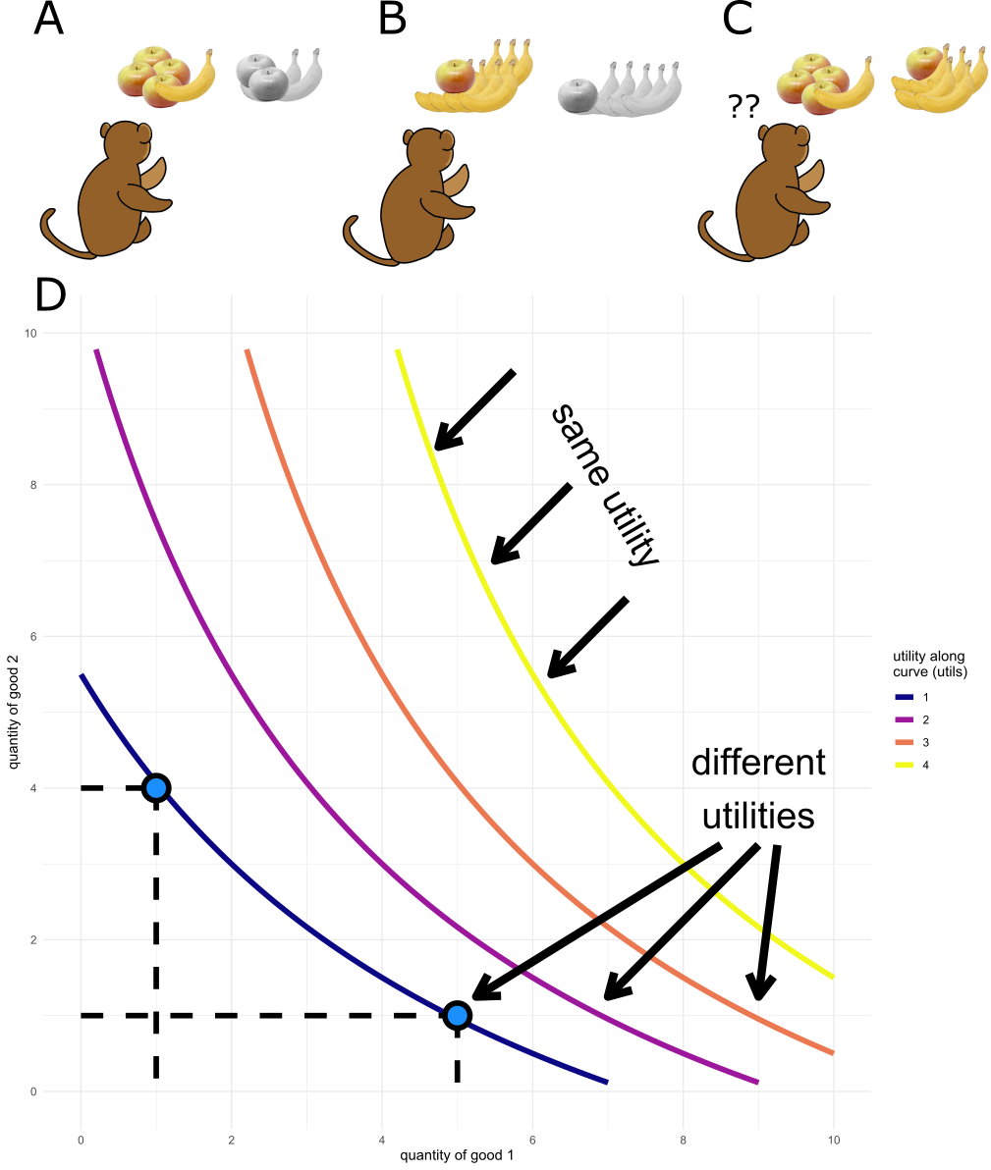
Figure 1a-d) Observations of an organism’s binary choices between bundles of goods allows for the construction of utility curves under revealed preference theory. In a-c) an organism chooses between bundles of goods (in this example, between amounts of apples $A$ and bananas $B$). In a) the offered bundle of 4 apples and 1 banana is more desirable than an offer of 2 of each fruit, and so the first bundle is chosen. In b) an offer of 7 bananas and a single apple is dominant over an offer of 5 bananas and a 1 apple and so the former is chosen. In c) the two offers (4 apples and 1 banana vs. 5 bananas and a single apple) are both preferred equally and will be chosen between as if at random. The organism is said to be indifferent between these two choices and they lie on the same utility curve. In d) an example indifference map is generated assuming the choices in 1a-c). Each point along a curve is a potential choice which carries the same utility to the organism. For instance, the choice offered in c) is highlighted on the lowest curve. As curves are drawn away from the origin, the utility they represent to the organism increases; the points along a curve offer more utility to the organism than any possible point below the curve. Each distinct curve is referred to as an ‘indifference curve’. All choices and values in this figure are hypothetical and are used for illustrative purposes only. Adapted from Pastor-Bernier et al. 2017.
However, this ordinal revealed preference theory of utility can only explain choices made between certain (riskless) choices. It was not until 1944 that von Neumann and Morgenstern showed that a cardinal utility function could be sampled from a subjects choices between risky gambles in their seminal work (von Neumann & Morgenstern, 1944). The authors proposed four axioms (a further two plus those above in equations 1.3 and 1.4) which any decision maker must satisfy if they can be said to be behaving as if they are maximising their expected utility (as defined in equation 1.2). These final two axioms are the axioms of continuity and independence, and are shown in equations 1.5 and 1.6:
Equation 1.5
$$∀X≾ Y≾ Z, ∃p∈[0,1]:pX+(1-p)Y\sim Z$$
For all choices where $X$ is preferred to $Y$, which itself is preferred to $Z$ (and so, by transitivity, $X$ is preferred to $Z$), there must exist some probability $p$ for which the composite of $p⋅X$ and $(1-p)⋅Z$ which is equal in preference to the second option $Y$.The continuity axiom dictates that the ordered choices of revealed preference theory can be compared on a continuous scale of utility where probability and magnitude of outcome are integrated.
Equation 1.6
$$∀X≾Y, ⇒∀Z and ∀p∈[0,1]: pX + (1-p)Z≾pY + (1-p)Z$$
In all cases where $X$ is at least as preferable as $Y$, then for any possible third option $Z$ and any possible probability $p$, the bundling of either the probability $p$ or the third option $Z$ to both sides of the original choice should have no effect on the preference of the first option over the second. If the first three axioms of this Expected Utility Theory (completeness, transitivity, and continuity) describe the shape of a utility function, the independence axiom states that preferences should be static. The order choices are presented in, or the addition of decoys to the presented choice should have no effect on which is chosen.
Any economic decision-maker that satisfies these four axioms can be said to be making choices as if they are trying to maximise their utility. Thus, the formalisation by von Neumann and Morgenstern allowed for measurement of an organisms utility from the binary choices they make between bundles of goods with given probabilities, and underpins the last half of a century of research into both human (Mosteller & Nogee, 1951) and animal (Ferrari-Toniolo et al., 2020; Genest et al., 2016; Pastor-Bernier et al., 2017) studies of economic decision-making. Even as many violations of the four axioms have been discovered during this time (see Allais, 1953 and Ellsberg, 1961 for two high profile violations, and Machina, 1987 for a more general review), Expected Utility Theory remains a cornerstone of research into economic decision-making and has been the driving theory behind the experimental paradigms employed in the literature. For a more in-depth view of its limitations and the development of more descriptive models in the past 50 years, see appendix 1.1.
Hedonimetry and the brain
If behavioural science tells us that animals act as if they are maximising the utility they receive, it is not unreasonable to suggest that a function of the brain is to track the utility of offered choices. If such a collection (or collections) of cells that encoded a common currency of utility across choice domains could be identified and their activity deciphered, it might prove possible to realise Edgeworth’s dream of a hedonimeter to fully measure the utility function of any decision. With full measurement and knowledge of the utility signal in the brain, the behavioural science fantasy of predicting any subject’s choices from any offered sets of options would be achieved.
The first evidence that such a population might exist came from studies of rats that would repeatedly self-stimulate via a lever connected to an electrode implanted in the basal forebrain (Olds & Milner, 1954). There is nothing intrinsic to any physical object that is ‘rewarding’; the concept of an object’s rewarding value comes from the reinforcement it produces to collect/do/eat more of it (Salamone et al., 2009). These implanted rats which will indefatigably press a lever to continue self-stimulating show the extreme positive reinforcement generated by stimulation of the basal forebrain, implying that activity of cells in the vicinity are conveying reward.
Later studies of intracranial self-stimulation (ICS) revealed the ipsilateral pharmacological oxidopamine (6-OHDA) lesions of the ascending dopaminergic fibres reduced the compulsion of rats to self-stimulate (Fibiger et al., 1987; Phillips & Fibiger, 1976). This implication of midbrain dopaminergic neurons which project to the striatum and frontal cortices in the reinforcing activity of ICS was further strengthened by studies which showed that levels of ICS were correlated with the presence of dopamine metabolites (Fibiger et al., 1987) and that animals were most reinforced to self-stimulate when electrode tips were placed within the ventral tegmental area (VTA) or substantia nigra pars compacta (SNc) with the volume of ICS correlating with the density of dopaminergic neuron cell bodies at this point (Corbett & Wise, 1980).
In addition to self-stimulating for current, rats will also press a lever to administer drugs of abuse intravenously. Injection of pimozide, a dopamine receptor antagonist, greatly increases the self-administration of amphetamines by animals in an effort to compensate for the reduced efficacy per volume of drug (Yokel & Wise, 1975). Similarly, 6-OHDA lesions to dopaminergic projections to the nucleus accumbens in the ventral striatum have also been shown to extinguish the self-administration of amphetamines and cocaine in rats (Lyness et al., 1979; Roberts et al., 1980) further implying dopamine’s role in the reinforcement of ‘rewarding’ behaviours. The incentive-sensitisation theory builds from these findings to posit that the mesolimbic dopamine pathway plays a central role in generating the craving for addictive drugs (Robinson & Berridge, 1993); maladaptive or not, the dopaminergic pathways robustly generate motivations which lead to choices, and thus have an important role in any measurement of inferred utility.
Physiologically, disorders of dopamine in humans have a marked effect on a patient’s motivations. Parkinson’s disease, which involves the destruction of dopaminergic neurons in the substantia nigra, is well known to induce apathy (a motivational deficit) in sufferers (den Brok et al., 2015), which can be lifted in many patients by the application of the dopamine precursor L-Dopa (Czernecki et al., 2002). In many patients, attempts to address the reduction in dopaminergic activity can lead to the opposite outcome of compulsive behaviour such as excessive gambling (Grosset et al., 2006) and hypersexuality (Romito et al., 2002). Dopaminergic dysfunction is also implicated in schizophrenia, a condition in which sufferers also regularly suffer from apathy. In such patients, ventral striatal responses to reward cues are dampened (Juckel et al., 2006).
As previously mentioned, choices and actions are only ‘rewarding’ insofar as they can reinforce said behaviour. Therefore, there is a crucial link between reward and learning. One influential model of learning dictates that the rate of learning depends on the association between a cause and effect, i.e. is as strong as the prediction of the effect from the cause (Rescorla & Wagner, 1972). The update in the association between such a cause (the conditioned stimulus) and effect (unconditioned stimulus) can be written as:
Equation 1.7
$$∆V_{x}^{n}=αβ\left(λ-\sum{V_{all}}\right)$$
$$V_{x}^{n+1} = V_{x}^{n}+∆V_{x}^{n}$$
$$x ∈ all$$
Where $V_{x}^{n}$ represents the strength of association between a cause and effect $x$ at a time, or trial $n$. This is updated for trial $n+1$ by taking the strength of association at time $n$ and adding the change ($Δ$) in strength of association that occurs during trial $n$. This change is determined by the salience of the conditioned stimulus in $x$ (a red sky in the morning might predict future rain as well as the distant rumble of thunder and lightning, but it is much less noticeable), specified by a parameter $α$, and the learning rate of the subject for the unconditioned stimulus $β$. These parameters then scale the prediction error term inside the brackets; the difference between the maximum associative strength $λ$ and the combined sum of associative strength for all stimuli present $\sum{V_{all}}$. I.e., the change in associative strength on trial $n$ is proportional to the difference between what is expected, $λ$, and what actually happens, $\sum{V_{all}}$.
The success of the Rescorla-Wagner model in predicting empirical learning findings such as overshadowing (the stronger conditioning to the most salient of group of conditioned stimuli) and blocking (the deficit in conditioning to a second conditioned stimuli when paired with an already perfectly conditioned stimulus; Miller et al., 1995).
This model was the foundation of later ‘temporal-difference’ (TD) models which made two important contributions relevant for the neuroscientific study of utility (Ludvig et al., 2012; Sutton & Barto, 1981). First, the Rescorla-Wagner model treats the trial as the unit of time, which is unsuitable for physiological learning which must happen continuously in real-time. It is conceivable that something learnt in the first half of a trial might be vital in the later half, or even on some later trial. Secondly, TD models employ a Markov approach to updating predictions where the difference in predictions at each time step are compared to each other and then to the unconditioned stimulus, also referred to as ‘second order conditioning’ (Sutton & Barto, 1990). For an intuitive example, consider an American Football team moving the ball down the pitch in separate plays (time-step) where the end result of each play carries a different future prediction of the unconditioned reward points (Daw & Tobler, 2013).
Temporal difference learning employs the Bellman equation (Bellman, 1957) to calculate the total value of a state $x$ at time $t$. Any such state has a reward immediately available $r_{t}$ (a pass into the endzone, in American football terms), but this may be vanishingly small (/unlikely). Any change to the state over time opens up new rewards to be sampled and new states to progress to. The reward $r_{t+1}$that a team can expect to sample will be predicated upon their current state, and so on as the decision tree unfurls. The Bellman equation can be written as:
Equation 1.8
$$V_{x}^{t} = r_{t}+E(r_{t+1}+E(r_{t+2}+E(r_{t+3}...|x_{t+2}|x_{t+1}|x_{t})))$$
Rewritten as
$$V_{x}^{t} = r_{t}+E(V^{t+1}|x_{t})$$

Any such huge decision tree in equation 1.8 can be simplified down into smaller steps that iterate recursively. The temporal difference error signal can then be expressed as the difference between any agent’s predictions of their current state and time and the former state and time.
These theoretical models had a profound effect on the search for a neural substrate of reward when reconciled with electrophysiological recordings of non-human primate midbrain dopaminergic neurons (Schultz et al., 1997). Such dopaminergic neurons typically have stereotyped responses to unpredicted rewards showing phasic activity with a duration of less than 200ms and a latency of <100ms (Ljungberg et al., 1992). This activity scales with the magnitude (typically measured in ml of a pleasurable sugary juice) of reward, and with the reward's unpredictability (Bayer & Glimcher, 2005); these neurons show the greatest increase in stimulus-related firing rate when the organism receives the most surprising, most preferred kind (e.g. flavour), and largest reward. Such responses of a single dopaminergic neuron to an unpredictable reward of juice recorded from the midbrain of a rhesus macaque over multiple trials are shown in figure 2a).
Crucially, this 'quantitative encoding' (Bayer & Glimcher, 2005) of the desirability extends to cues which predict a future reward (Mirenowicz & Schultz, 1994). Indeed, as a conditioned stimulus for reward becomes established, dopaminergic neurons gradually increase the stimulus-related phasic activity corresponding to the presentation of the conditioned stimuli, and decrease stimulus-related phasic activity at the time of the reward delivery. For a perfectly temporally predictive cue-reward relationship, the only change in dopaminergic firing rate is seen when the conditioned stimulus is presented and there is no change in reward-related dopaminergic firing rate (W. Schultz et al., 1997). The changes in firing rate of a single dopaminergic neuron evoked by a fully conditioned stimulus and reward are shown in figure 2b).
This change in firing rates to these two stimuli presentations can be explained using the prediction error paradigm described above. A subject to whom it has been signalled that a reward will occur with 100% reliability in exactly n seconds will have no prediction error at the actual receipt of reward. This temporal-difference 'reward-prediction error' (RPE) is what the dopaminergic neurons are signalling with their change in activity (D’Ardenne et al., 2008; W. Schultz et al., 1997). The compatibility of this signal with temporal-difference (rather than the foundational Rescorla-Wagner) models is supported by a study by Montague et al., who showed that rewards could be predicted from sequences of conditioned stimuli. Such sequences are only compatible with the higher-order prediction errors of temporal-difference learning.
If the change in firing rate of these neurons is correlated to the reward-prediction error of a pair of conditioned and unconditioned stimuli, it should hold for when this error is negated, i.e. when a reward is predicted, but does not arrive. Such a relationship is observed (Schultz et al., 1997) and an illustrative example is presented in figure 2c). In addition, punishments, and conditioned stimuli for future punishments, have been shown to also inhibit dopaminergic firing rate (Mirenowicz & Schultz, 1994).
A Dopaminergic Neural Substrate of Utility
The change in dopaminergic neuron firing rate encodes a reward-prediction error, with responses correlated with the physical components of expected value, i.e. reward magnitude and probability (Fiorillo et al., 2003; Tobler et al., 2005). However, as discussed, physical components alone cannot account for an organism’s level of utility received. Instead, expected utility theory formalises the calculation of the utility present in any choice by observing the behaviours of a choosing subject.
Recent behavioural experiments in mice (Kim et al., 2012), rats (C. Y. Chang et al., 2015; Steinberg et al., 2013), and monkeys (Stauffer et al., 2016) have shown that optical stimulation of 'mimic' dopaminergic RPE activity is sufficient to drive learning and choice behaviour (Stauffer et al., 2016). Conversely, disruption of the ability of dopaminergic neurons to produce burst firing by genetic inactivation of NMDA receptors led to mutant mice that had attenuated performance on a bandit choice task (Zweifel et al., 2009), implicating these cells as a neuronal substrate of utility.
Lak et al., 2014 furthered this by studying the dopaminergic activity of midbrain neurons in rhesus macaques making choices that differed by magnitude, probability, and type of consumable good (either flavour of juice, or juice versus mashed banana). Monkeys showed complete and transitive choices, i.e. choosing as if satisfying some integrated quantity (utility) rather than separate reward dimensions. The RPE activity of single neurons recorded in this study reflected this unitary scale, rather than the separate attributes of the goods, suggesting that the prediction error of dopaminergic cells is, in fact, a utility prediction error.
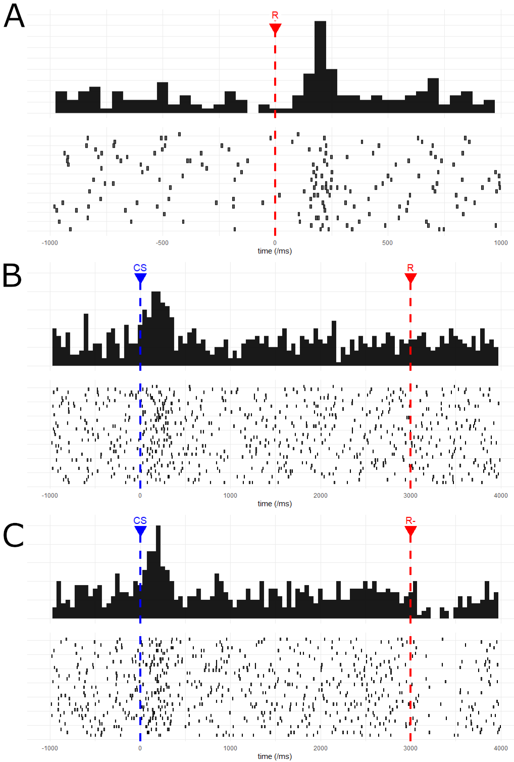
Figure 2a-c) Single dopaminergic cell responses to rewards and conditioned stimuli. In a), the responses of a single non-human primate dopamine cell recorded during this project to an unexpected juice reward are shown. Reward was delivered at time 0 and the responses of the cell are shown as a post-stimulus time histogram (top) and as a raster plot (bottom) of single spikes from this cell. The phasic response of the cell can be seen starting at 100ms and continuing for a further 200ms. As our task contains many epochs where stimuli are presented, and as we never withhold a predicted reward during our task, for panels b) and c) we use wholly simulated data to illustrate the widely reproduced change in activities of dopamine neurons upon conditioning of stimulus (b) and when a predicted reward is not forthcoming (c). For biological data, see Schultz et al., 1997. In b) a conditioned stimulus (CS) cue is presented at time point 0, predicting a reward at 3000ms. The firing rate of the simulated dopaminergic neuron increases at time 0 with the CS presentation rather than at time 3000 with the delivery of the reward. In c) the same CS cue is shown at time 0 but in these trials a predicted reward is never delivered. The simulated neuron maintains phasic activity at time 0 but shows a decrease in firing rate upon the omission of the predicted reward. Fix axis labels size and size of fig

Aside from the physical components, another important dimension rewards can vary along is the effort and time taken to receive said good, i.e. “a bird in the hand is worth two in the bush”. If dopamine signalling is incorporating all of the dimensions of a possible reward into a unitary scale, these two should be encoded. Day et al., 2007 used voltammetry to study dopamine released by midbrain projections to the nucleus accumbens in rats. In forced choice trials, significantly less dopamine was released (with the implication that therefore this is also less neuronal spiking activity from the upstream dopaminergic neurons, but see) when the obligated good was either delayed, or required repeated lever presses (had a high effort cost). Single cells dopaminergic activity in macaques have since been shown to reduce in a hyperbolic manner as rewards are time discounted (Kobayashi & Schultz, 2008), and a recent study has extended the idea of folding effort into the unitary scale of utility encoding in macaque dopaminergic neurons (Burrell, 2019).
Finally, employing an experimental paradigm using gambles to construct the utility function (the 'fractal method'; Machina, 1987), Stauffer et al. found that the normalised dopaminergic phasic activity associated with reward increased in a non-linear manner as the expected value of a gamble increased linearly. Such non-linearities in utility-versus-value are the foundational theoretical finding from Bernoulli’s work on the St. Petersburg paradox. That the increase in dopaminergic cell firing mirrors this asymmetry is more evidence that the activity of these dopaminergic projections is signalling a utility-prediction error.
Though we have focused on the dopaminergic midbrain in this introduction (and throughout the rest of this thesis), it should be noted that other areas of the brain have also been proposed as encoding economic value. Given the fundamental importance of economic decision-making to the survival and well-being of humans, and other animals, it is hardly surprising that these decisions might involve the integration of multiple regions of the brain (Grabenhorst et al., 2012; Padoa-Schioppa & Assad, 2006). For greater detail on the anatomy of the brain circuits thought to underpin reward processing, and the evidence for other regions of the brain’s involvement in these circuits, see appendix 1.3.
As a putative neural substrate for utility in the brain, we spend the remainder of this thesis discussing and analysing the behaviour of non-human primates on a task that elicits utility from choices on a trial by trial basis. This behavioural utility is then used to investigate the activity of recorded midbrain dopaminergic neurons in these animals.

Appendix 1.1 – Modern Advances in Behavioural Economics and Auction Theory
This thesis considers the behaviour and neuronal responses of trained macaques in an auction task (BDM) hitherto only used in human studies of economic decision-making. As such, we feel that any interested reader only need be introduced to three behavioural-economic concepts in the introductory chapters of the thesis:
- The idea that utility and not value is the variable by which economic decisions are made. I.e. people and other organisms maximise their utility by consulting a utility function when choosing between distinct options. Compare equations 1.1 and 1.2 when discussing the St Petersburg paradox in the first chapter.
- That in order to make these decisions some areas of the brain must have access to these internal representations of utility. For instance, we discuss Lak et al., 2014, which shows how dopaminergic neurons of the macaque midbrain integrate information across different dimensions. In Chapter 1 of the thesis we focus on dopaminergic circuits, branching out to discuss the evidence for other components of ‘the reward circuit’ (Haber & Knutson, 2010) in appendix 2.
- Finally, we discuss the incentive-compatible nature of the BDM, a mechanism by which subjects report their cardinal utility for a good on a single trial. Chapter 2 walks through the theory of the BDM and what makes it such a potentially attractive task for the cognitive sciences.
However, there has been much interesting progress in the fields of micro- and behavioural economics over the past half a century which goes beyond the requirements of this thesis. We use this appendix to briefly discuss three examples we find most interesting.
Prospect Theory
We close discussions of economic utility theory in the first chapter by mentioning violations of the four axioms of Von Neumann and Morgernstern’s utility model. Of particular note is the ‘Allais paradox’, first described in the literature by Allais, 1953 and adapted in figure 1 from Kahneman & Tversky, 1979. A participant is asked to make two choices, between options A and B, in gambles 1 and 2:
Gamble 1:
Choose between option A where there is a 33% chance of winning $2,500, a 66% chance of winning $2,400, and 1 % chance of winning nothing, OR option B which represents a certain $2,400.
Gamble 2:
Choose between option A where there is a 33% chance of winning $2,500 and a 67% chance of winning $0, OR option B where there is a 34% of winning $2,400 and a 66% chance of winning $0
In their experimental reproduction of Allais, 1953, Kahneman & Tversky found that 82% of 72 participants chose option B in gamble 1 and 83% chose option A in gamble 2. However, this is a violation of the independence axiom (equation 1.5) as options A and B in gamble 1 and 2 are identical except for addition of independent extra alternative choice of $2,400 with a constant probability (66%). A graphical explanation of this paradox is shown in figure 1.

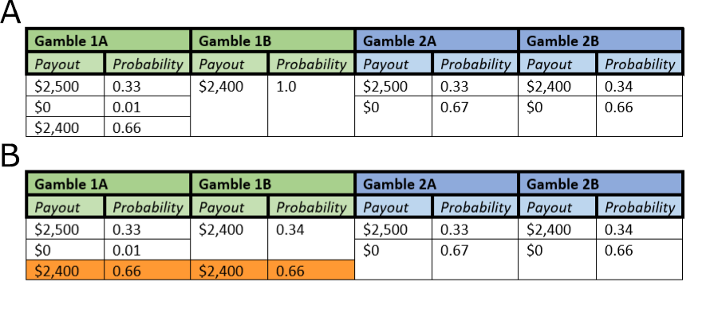
Figure 1a-b) The Allais paradox highlights a violation of the independence axiom. Participants are asked to choose between two options (A and B) in sequential gambles (1, green, and 2, blue). In a) participants are asked to choose which option from gamble 1 and gamble two they would choose. In Kahneman & Tversky, 1979, 82% of 72 subjects choose gamble 1B and gamble 2A. However, in b) it can be shown that gamble 1 and gamble 2 should have the same relative desirability of options. Gamble 1 is derived from gamble with the addition of a 0.66 chance of $2,400 added to each option (orange). Thus, the switching behaviour between options A and B originally found by Allais, and also Kahneman & Tversky, represents a violation of the independence axiom.
In chapter 1 we define the utility function of a set of choices in equation 1.2 as
Equation A1.9
$${EU}_{i,n}= p(x_{n})⋅{υ_{i}(x}_{n})$$

Where the probability term ($p(x_{n})$) is separate from the subjective, utility term $υ_{i}(x_{n})$. That is, probability is treated objectively whereas other components of value (e.g. magnitude) are treated subjectively. This idea was further extended by a later paper by Tversky & Kahneman in which subjects were asked to choose between three responses to a hypothetical deadly, novel disease:
Imagine that the U.S. is preparing for the outbreak of an unusual Asian disease, which is expected to kill 600 people. Two alternative programs to combat the disease have been proposed. Assume that the exact scientific estimate of the consequences of the programs are as follows:
Choice 1:
If Program A is adopted, 200 people will be saved. If Program B is adopted, there is 1/3 probability that 600 people will be saved, and 2/3 probability that no people will be saved. Which of the two programs would you favor?
Choice 2:
If Program C is adopted 400 people will die. If Program D is adopted there is 1/3 probability that nobody will die, and 2/3 probability that 600 people will die. Which of the two programs would you favor?
(taken directly from Tversky & Kahneman, 1981)
For any choice, the expected number of deaths is equal. Either 400 people will certainly die (A and C), or 400 people will be expected to die (B and D). Participants are choosing between a sure thing and a risky choice with equivalent values. We would assume subjects would show consistent risk preferences between the 2 choices: either they go for the risky option in both choice or the ‘safe’ option. However, the framing of the choice as either losses or gains (‘200 people will be saved’ vs. ‘400 people will die’), has a distinct impact upon participants choices; they are risk averse and choose option A in choice 1, but are risk-seeking and choose option D in choice 2.
These violations of Von Neumann/Morgernstern utility theory were codified by Kahneman and Tversky into a descriptive model of decision making known as ‘Prospect theory’ (Kahneman & Tversky, 1979). The key insight made was that probability should be treated subjectively, that is
Equation A.10
$${EU}_{i,n}= ω_{i}(p(x_{n}))⋅{υ_{i}(x}_{n})$$
Where $ω$ is some distortion a subject $i$ places upon the probability of outcome $x_{n}$. This leads to a further two appreciations of how an individual’s utility function is shaped. Firstly, that this $ω$ parameter creates as S-shaped distortion where people overweight low probabilities and underweight high probabilities (figure 2a). Secondly, the idea that “losses hurt more than gains”, i.e. if an organism loses something of value, to return to net zero utility for the time period, they must gain something of greater value than that which was lost. This is formally described as ‘loss aversion’ and depends on the framing (see the above experiment using a potential novel disease) of any transaction and gives rise to the ‘endowment effect’ discussed in chapter 2. This ‘kink’ in the utility function is shown in figure 2b.
While newer models have arisen to account for some failings of Prospect theory (and especially to incorporate ‘heuristics’ into descriptive models of economic decision-making; Tversky & Kahneman, 1992), the theory still represents a step forward in combining insights from psychology and ‘experimental’ economics into the previously much more theoretical economic framework. Though undoubtedly not perfect, has proved its worth in empirical studies of humans (Abdellaoui et al., 2008; Scholten & Read, 2014) and macaques (Stauffer et al., 2015). In 2002, Daniel Kahneman won the Nobel Prize in economics for "for having integrated insights from psychological research into economic science, especially concerning human judgment and decision-making under uncertainty”.
Stochastic Choice and Random Utility
Within this thesis we present a task which allows us to study the cardinal utility of a good to a monkey on individual trials (chapter 2). We compare this task to the discrete-choice tasks that have traditionally been used in this field. In such ‘binary choice’ tasks, subjects choose been options A and B, with the implication being that the good with the higher utility will be chosen.
For a hyper-rational decision-maker, we might expect that these choices are black and white- after all, the participant should always choose the better option! However, when studying the choices made by both humans (Mosteller & Nogee, 1951) and monkeys (Ferrari-Toniolo et al., 2020; Pastor-Bernier et al., 2017), many choices instead show a curve or preferences (see figure 2.1 for a simulated example or figure 2.7 for a figure redrawn from Mosteller and Nogee, 1951). In the introduction to this thesis we touch upon the differences between ‘perceptual’ decisions (e.g. sensory discrimination tasks) and ‘economic’ decisions. The indifference curves in figures 2.1 and 2.7 bear a striking resemblance to the psychometric curves found in the perceptual literature (Klein, 2001; Rieskamp et al., 2006); instead of always choosing an offer with higher utility, subjects make ‘stochastic’ (or ‘discrete’) choices.
There are two reconciliatory theories of these empirical observations of choice reversal. Fixed utility theories assume that the utilities present in a choice are fixed and subjects choose options in proportion to the value of the offered choices (Luce, 1959; Tversky, 1972).
Equation A1.11
$$p(x_{i})=\frac{υ_{i}(x)}{\sum_{j=1}^{n}{υ_{i}(x_{j})}}$$
The probability of a subject $i$ choosing an offer $x$ is equal to the utility of that choice to the subject, divided by the sum of the utilities of all other offers.

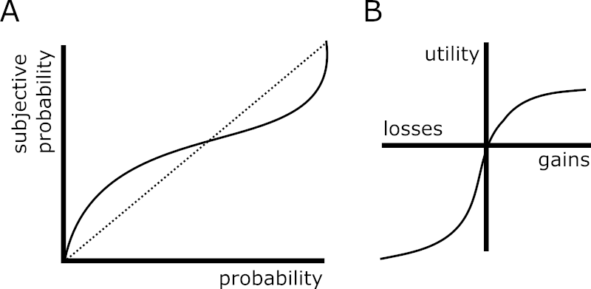
Figure 2a-b) Prospect theory incorporates evidence that probabilities are experienced subjectively by individuals. In a) the S-shaped curve of the probability distortion is shown. Low probabilities are subjectively overweighted (and seem to occur more often than they actually do) whereas objectively high probabilities are underweighted. In b) the ‘kink’ of the utility curve is shown where the convex function for losses is steeper than the concave curve for gains. I.e. “losses hurt more than gains”.
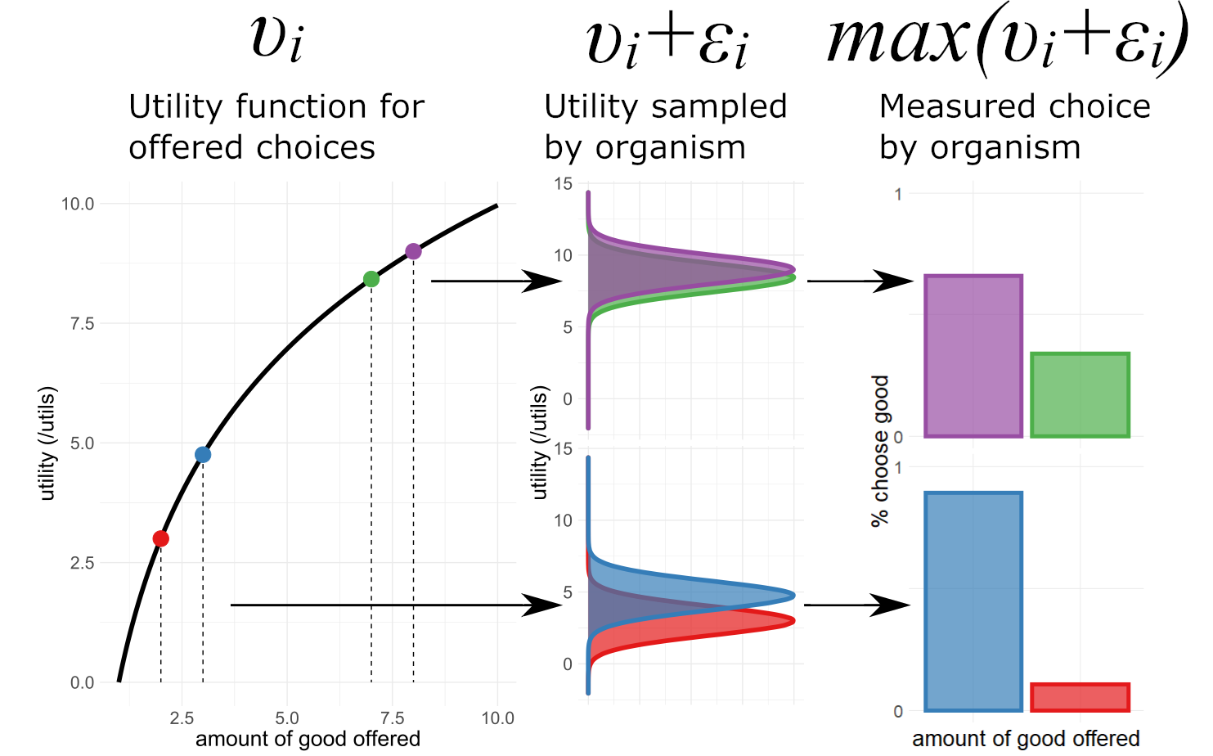
Figure 3) Random Utility Models assume that the organisms sampling of the utility of an offered choice incorporates and error term. For given choices (e.g. between 2 and 3 units, red and blue, of a good, or 7 and 8 units, green and purple, of a good) and organism samples a utility function (black curve for utility given offer in first panel). This utility function takes the form $υ_{i}$ and is internal to the organism. We expect the organism to preferentially choose the option with the higher internal, subjective utility. Random Utility Models posit that the choice the organism makes is between this utility for the good plus an error term $ε_{i}$ which in this figure takes a Gaussian function in panel 2. In panel 3 the sampled utilities are compared and in each simulation the choice with the higher sampled utility $υ_{i}+ε_{i}$ is chosen. The fraction of choices the organism would be expected to make is then shown. For a given error term, the choices are expected to be made in proportion to their utility as derived from the utility function $υ_{i}$. Data here is simulated and for illustrative purposes only.
In contrast to fixed utility theories, random utility theories assume that the utility placed on a choice by a subject is sampled from a distribution at each evaluation and is inherently noisy (Becker, Gordon M. DeGroot, Morris H. Marschak, 1963; Marschak, 1960; McFadden, 1982). 1 millilitre of orange juice might have greater mean utility to a monkey than 1 millilitre of blackcurrant juice and over infinite trials might be chosen more often. However, if both utility distributions have significant variance, both options might be chosen with a similar rate over a countable number of choice actions. Daniel McFadden showed that the Luce equation (equation A1.2) could be reinterpreted in terms of logistic regression. Namely that the choice $p(x_{i})$ can be estimated using a multinomial logit model (McFadden & Train, 2000)
Equation A1.12
$$p(x_{i})=\frac{e^{υ_{i}(x)}}{\sum_{j=1}^{n}{e^{υ_{i}(x_{j})}}}$$
The slope of this model is proportion to the noise in a subjects choices; a rectangular step function shows hyper-rational choices of always the offer with the most utility, with the curve flattening as a subject’s choices become noisier. Daniel McFadden won the 2000 Nobel Prize in economics for these contributions to discrete choice modelling and we use this model in chapter 3 to estimate the utility of binary choices, in line with previous studies from the lab (Ferrari-Toniolo et al., 2020; Pastor-Bernier et al., 2017).
Figure 3 shows the random utility model in graphical form where choices red, blue, green, and purple sit along a concave utility function (panel 1). We model the noise in each choice as a Gaussian (here with equal variance (noise) per choice which may or may not be the case in the real world), where the proportion of choices corresponds to the proportion of samples where each has a higher utility plus noise (panel 3). The choice between the red and blue offers (representing 2 or 3 units of an offered good) sits on a steeper section of the utility function and so, for the same amount of noise in each choice, has a greater discrepancy in observed choices than for the green and purple (7 and 8 units) goods.
Modern Auction Theory – From Wives to Wireless
This project uses a relatively simple auction design in which a monkey makes bids which are compared to a randomly drawn computer bid. We discuss a history and analysis of the BDM auction paradigm in chapter 2 of this thesis (Becker paper, milgrom paper). While this is not a pure economics thesis, we consider it important to situate our work somewhat within the more general field of auction theory. Neuroeconomics as a discipline is in its infancy (Camerer et al., 2005) and we would expect that some day, possibly even soon, an understanding of the economics literature will be an important asset to any neuroscientist who goes in search of value signals in the brain. Here we give a whirlwind tour starting with the history of auctions and progressing onto modern auction theory.
The somewhat chequered history of auctions is generally agreed to have begun with Herodotus' description of the sale of Babylonian wives in his Histories published circa. 500 (Rawlinson, 1885).
"All the girls of marriageable age were assembled together in one place, and a crowd of men would form a circle around them while and auctioneer had the women stand up one by one and sold them, beginning with the most beautiful. When this young woman was sold for a large amount of gold, he would then put up for sale the second most beautiful... All the wealthier Babylonian men of marriage-able age would try to outbid each other for the prettiest girls. The more humble among them did not seek beauty in the women they bid for, because the homelier ones came with a monetary reward as an incentive for someone to marry them... And when the auctioneer finished selling the most beautiful of the young women, he had the most unattractive stand up, or a crippled girl, if there was any among them, and these would be offered for sale with the announcement that they would go to whoever would accept the smallest amount of gold and marry them... The gold for these arrangements came from the sale of the beautiful girls, and thus the attractive provided the dowries to help marry of the unattractive and crippled."
Each potential suitor is assumed to have utility for both a beautiful wife and the potential monetary compensation offered. The rich outbid each other to maximise their utility for the 'prettiest girls' and the poorer men to maximise the monetary incentive for marrying a more 'humble' bride.
Perhaps a more famous early example of auctions is also its most disastrous. In 193AD the Praetorian guard murdered the Roman emperor Pertinax and auctioned off the chance to succeed him. Pertinax's father-in-law Sulpicianus offer of 5000drachmas was outbid by Didius Julianus who offered 6000drachmas (Gibbon, 1776). While auctions are an efficient mechanism to discover an individual’s utility for an offer, they are a poor apparatus to aggregate many people's preferences; the purchase rather than earning of the title made Julianus an unpopular emperor who was executed by the same guards less than 3 months later (Dio, n.d.).
The Romans had greater success staging auctions for more common goods in order to trade and raise money, most commonly to pay off debts to creditors (Morcillo, 2008). For the last few centuries, particular industries especially for rare items (such as diamonds), fresh items (such as fish and fresh flowers) and durable items (such as used cars) have, and continue to sell their goods in auctions, however, it is only with the advent of the modern world that the use of auctions has exploded.
The United States introduced auctions for treasury bills in 1929 (Garbade, 2008), a mechanism of government financing that has since been taken up by many countries and is now worth tens of trillions of dollars worldwide. In addition, certain natural monopolies where the opportunity to exploit a resource can only be sold to one bidder have proven amenable to auctions. For instance, when selling the rights to extract oil from a potential field, the utilities of petroleum companies will vary by their estimate of the magnitude of that oil reserve, and any regulator is incentivised to find the highest estimate among any set of bidders.
With the rise of telecommunications, frequency spectra became a crucial and inherently limited natural monopoly and by the new millennium auctions of spectra raised tens to hundreds of billions of euros per country (Klemperer, 2002). The internet allowed monopolisitic startups the opportunity to auction limited advertising space (Google, 2017) as well as connecting traders with an near infinite supply of potential buyers on platforms such as eBay.
It's therefore not surprising that auction theory has proved a fertile ground for applied economic thought over the last half a century providing insights that have raised billions of units of currency for governments around the world, and many prestigious prizes for economists. The modern analysis of auctions is traditionally traced back to John Forbes Nash's 1950 dissertation on non-cooperative games (Nash, 1951). Extending the work of von Neumann and Morgenstern beyond zero-sum games (von Neumann & Morgenstern, 1944), Nash introduced the concept of a 'Nash equilibrium', an optimal strategy for any player given full knowledge of every other player's strategy, which must exist for any finite game (that is, any game with a bounded set of strategies such as the limited bidding budget in our BDM task).
Nash shared the 1994 Nobel prize in economics that he won for his work on non-cooperative games with John Harsanyi for the latter's work on 'Bayesian games', when players have incomplete information about the game being played (Harsanyi, 1967, 1968a, 1968b). For example, if a PhD student knows that their examiners are diligent the Nash equilibrium should land on the student putting a fair bit of work even into the appendix of their thesis to produce a comprehensive piece of work to be examined upon. However, any student has incomplete information about their thesis committee and does not know if their examiners will be diligent or lazy (and not read the appendices), or perhaps just not interested in auction theory. In auctions, a bidder only has complete knowledge of their own value and range of bids for any offered good, and so any analysis of auctions must take place within the Bayes-Nash framework.
The extension of game theory to incomplete information settings becomes crucial when considering the phenomena that has come to be known as “the winner's curse”. In 1971, Capen, Clapp, and Campbell published their reports that oil giants bidding for the rights to extract from offshore locations under a first-price auction mechanism were making less profit from these sites than expected (Capen, E. C. Clapp, 1973). All else being equal, by definition, the company which won the rights to drill an oil field had the greatest expected value of the oil located within that field. That is, after all, why they submitted the highest bid and won the auction for those rights. For any bidders lacking introspection, the greatest bid for a given good will tend to be the greatest overestimation in that goods worth, with the overestimation of value correlated with the numbers of bidders in the auction.
Robert Wilson solved the amount each bidder should optimally reduce their bid in such auctions by an analysis of auctions within the Bayesian games framework (Wilson, 1967). This work was expanded upon by Wilson and his former student Paul Milgrom in two seminal papers (Milgrom & Weber, 1982) with two key results for auction theory. Firstly, that it is possible to rank the expected income from an auction on a good based on the type of auction that is used. For instance, the English (the traditional mechanism used at auction houses where bids are open and gradually increase) auction and sealed second-price auctions (i.e. Vickrey auctions; the BDM mechanism but against conscious opponents) are functionally equivalent, but the open nature of the English auction mechanism reveals greater information about bidders valuation of goods. Therefore, any ignorant bidder can gather more information about the value of the auctioned good mitigating the winner's curse and leading bidders to bid more aggressively. English auctions typically raise more revenue than sealed second-price auctions, and both of these raise more than Dutch (descending price) auctions.
This feeds into the second main finding that it is in the interest of sellers to reveal as much information of their valuation of a good as possible. For instance, when selling a used car, auctioneers should provide proof that the car can run safely so that bidders can be more sure they will not fall victim to the winner's curse and will be incentivised to bid higher. Milgrom and Wilson termed these findings the 'linkage principle'.
Wilson and Milgrom's theoretical work in turn led to greater empiricism in auction theory. Throughout the 1950s and 1960s Vernon Smith had carried out experimental auctions on classes of economics students (Smith, 1991). These experiments grew more sophisticated and two papers published in 1980 and 1982 found similar empirical violations to revenue equivalence for 'identical' auctions to Milgrom's theoretical papers (Coppinger et al., 1980; Cox et al., 1982). Vernon Smith shared the Nobel prize in economics for his work on experimental auctions with Kahneman in 2002. In 1986, Kagel and Levin also carried out experimental work into the winner's curse, confirming both the real-world behavioural findings of Capen, Clapp, and Campbell, and the theory laid out by Milgrom (Kagel & Levin, 1986).
These theoretical and experimental results are interesting by themselves, but perhaps the single area where auction theory has distinguished itself over the last thirty years is in its successful application to real-world auctions. The mobile phone spectrum is inherently limited by the range of frequencies usable, and thus, is extremely valuable to telecommunications companies. Prior to 1993, the United States allocated spectrum via lottery and belief in free market mechanisms to encourage spectrum trading, leading to inefficiencies and zero revenue for the federal government. Among others, Milgrom and Wilson were invited to design auctions for the selling of spectrum in 1994 settling on the Simultaneous Multiple-Round Auction (SMRA) mechanism (McMillan, 1994). Similar spectrum auctions since then have raised over $60billion in revenue for the government and the efficient sorting of the natural monopoly has allowed wireless communication technology to flourish. Milgrom and Wilson were awarded the 2020 Nobel prize in economics for both their theoretical treatment of auctions and this successful application of the theory.
In the United Kingdom, similar auctions have also been used to great success. In 2000, Britain sold third generation spectrum licenses, raising £22.5billion in a single auction, described as the 'biggest auction ever' (Binmore & Klemperer, 2002). Not all spectrum licenses have been such a success, with many European auctions at around the same time failing to raise anywhere near that amount (Klemperer, 2002), highlighting the crucial role of continual research into auction theory and behaviour to allocate scare resources.
As Binmore and Klemperer note in their introduction, “Twenty-two and a half billion is a great deal of money to raise for selling air, but that is what the British government raised in an auction for five telecom licences“. This quote neatly summarises the power of gradual advancements in microeconomic theory over the past century. We have progressed from the failures of the Praetorian guard and Johann Wolfgang von Goethe, to the mathematical study of games ,and finally to governments worldwide “putting auction theory to work” (Milgrom, 2003).

To do:
- Idea of preference as constructed at the choice
http://bear.warrington.ufl.edu/brenner/mar7588/Papers/slovic-ampsy1995.pdf
slovic 1995 – the construction of preference
- Finish off ideas in the conclusion
- Get permission for summerfield figure and write up figure box
Appendix 1.2 – Where does value come from?
We open this thesis with the idea that utility is to choices as reproductive fitness is to innate behaviour. As genes give rise to phenotypes to maximise their reproductive success, some process in the brain is generating some internal sense of value that guides the choices an organism makes and the sense of reward, and thus reinforcement, they accrue from it. In the introduction to the thesis, we introduce the idea of utility, and the formalisation of Expected Utility Theory by von Neumann and Morgenstern (von Neumann & Morgenstern, 1944).
Though we think the results presented in this thesis have merit (and indeed merit the awarding of a doctorate) and show that the BDM mechanism can be used to glimpse the physiological substrate of utility, we are clearly only at the beginning of an arduous course of research to fully uncover the computations performed by organisms to make economic decisions; currently we only glimpse these through a scanner, darkly.
We use this thesis to place ideas and discussions we have had over the last three and a half years. These mostly boil down to the idea that if dopamine is ‘a neural substrate of prediction and reward’ (Schultz et al., 1997) then what does that mean. Obviously these questions are not limited to dopaminergic neurons (see appendix 1.3), and indeed we spend the end of this appendix discussing a similarly formulated question that focuses on the prefrontal cortices; ‘where does value come from?’ (Juechems & Summerfield, 2019).
Where does the theory of value come from?
For most people, considerations of value likely begin and end at the price of various consumer goods. Prices, and the willingness of consumers to pay them, are the signal by which the majority of the world’s economy is arranged, however, to a consumer they can seem as if they are divinely ordained. Some higher power has decided that good X costs £Y (give or take some small error between shops and over time). In order to explain how economies work, much of the history of economic thought has sought to explain this key signal: what leads an object to be labelled with a specific price?
‘Classical’ economic approaches to this question initially settled on the idea that value was intrinsic to the good being sold. Adam Smith originally formulate the idea that the cost of labour put into offering a good for exchange is “ultimate standard by which the value of commodities… can be estimated and compared”, later termed the ‘Labour Theory of Value’ (A. Smith, 1776). This was expounded upon by Ricardo who relaxed the theory stating that the price of a good is merely proportional to labour (Stigler, 1958). This idea of the value of a good being embodied by the cumulative labour necessary to produce it is a fundamental property of Marxist economic thought, with the difference between the value (i.e. the labour supplied) and the price of a good representing the surplus value (commonly termed S), i.e. the exploitation of labour (Marx, 1867).
At the very beginning of this thesis, we skip over this century of economic thought between Bernoulli’s formulation of utility vs value, and its rise to prominence in ‘neoclassical’ economics, among which is the idea that value is generated internally by a consumer. Furthermore, we only briefly touch on the neoclassical economic thought to discuss Edgeworth’s invention of indifference curves for choices (Edgeworth, 1881) and do not consider the prices of goods in the market.
Two other proponents of this school were William Stanley Jevons, who in 1862 (published Jevons, 1866) outlined the idea of marginal utility as the driving force behind prices, and Léon Walras, who took this idea further with his idea of a ‘general equilibrium’ (Walras, 1874). In such an equilibrium, each subject maximises their utility while ‘clearing’ a market (i.e. there is no leftover supply or demand in the economic environment). Such a toy equilibrium is shown for two monkeys trading bananas and apples in figure a2.1, extending Edgeworth’s portrayal of indifference curves illustrated in figure 1. The marginal utility of each good, represented by the indifference point, is the key contributor to each monkey’s demand for the two fruits provided which along with the initial allocation (the supply) will give rise to prices. This role of marginal utility in determining the demand for goods is key to solving Adam Smith’s ‘diamond paradox’. Though the first unit of water supplied to a dehydrated person is worth more than the first unit of diamonds, in general water is plentiful, so an additional unit of diamonds contains more marginal utility.
The capstone of Walras’ theory of value were extensions by Ken Arrow and Gerard Debreu in their 1954 model of general equilibria in markets, for which the former won the Nobel prize in economics in 1972 (Arrow & Debreu, 1954). Arrow and Debreu showed that, with some assumptions, a competitive market should arrive at prices which balance the supply and demand (i.e. the utility) of goods across the entire range of products.
Overall, the neoclassical school of economics and their ‘marginal revolution’ showed that goods do not have an intrinsic worth. As Carl Menger stated (Menger, 1950):
“Value is thus nothing inherent in goods, no property of them, nor an independent thing existing by itself. It is a judgment economizing men make about the importance of the goods at their disposal for the maintenance of their lives and well-being. Hence value does not exist outside the consciousness of men”

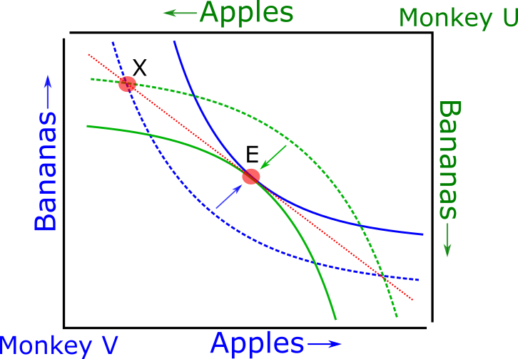
Figure a2.1 Neoclassical theories of utility provide the framework for Walrasian equilibria. Imagine our monkey from figure 1 choosing between apples and bananas has a partner, and we name these monkeys ‘Monkey U’ and ‘Monkey V’ (in line with the results chapters of this thesis). Both monkeys have indifference curves between apples and bananas as in figure 1 (blue and green; in this case symmetrical, though in practice probably unique to each organism). An initial allocation of apples and bananas ‘X’ leaves Monkey V with more bananas than apples, and vice-versa for Monkey U. These allocations lie upon indifference curves of low utility for both animals (dashed lines). A Walrasian equilibrium can be found where the monkeys trade the good they have a surplus of for the other, up to a point which lies upon the indifference curve representing the maximum achievable joint utility for both monkeys (‘E’; solid lines). At point E, both curves intersect along a tangent (red, dotted line), the slope of which is equal to the ratio of the price for bananas and the price for apples (in terms of each other) for both monkeys.
Do we like value or do we want it?
The idea of utility as something internal to an individual’s mind remains a key tenet to economic thought. However, it raises the question of where this utility arises from. Throughout the main body of this thesis we dodge this question, regarding animals as ‘utility maximising’ computers who will seek out the greatest reward (defined as anything which reinforces the behaviour to receive said reward). For the study of whether and how monkeys perform auction tasks and the correlates of dopaminergic neuron firing during these tasks, this is a satisfactory definition. For this reason, experiments of reward use objective dimensions of reward, in this case, the magnitude of juice offered, but also commonly, the probability or even the quantified nutritional content (Grabenhorst & Rolls, 2014). More certain and larger rewards containing necessary nutrients are dominantly rewarding over those that are less likely to be delivered, are smaller, or do less to satisfy basic physiological needs. We ‘want’ to maximise the rewards we obtain in the same way that a computer program ‘wants’ a higher score on a video game (Mnih et al., 2013) or to win a game of chess (Silver et al., 2018).
However, in practice humans and other animals do not spend their entire lives chasing rewards. When possible, that is, when the organism has accumulated enough of these base desires, organisms can expend the temporal, social, or indeed monetary capital. Indeed, in the colloquial usage of the word ‘reward’, many of the experiences people list as the most rewarding (such as travelling and time spent with partners and family) revolve around experiencing pleasure unrelated to physiological needs. Even when these ‘wanting’ and ‘liking’ overlap in a single good it is relatively clear that they are not the same thing. For instance, when viewing films at a cinema, the author regularly takes along a large bag of sugary sweets. Though he is able to space the first few out across many minutes and enjoys the pleasurable sweet taste of them, invariably by the end of the first hour or so this is replaced by a craving to continue eating even as the ‘liking’ response has been diminished or perhaps even reversed.
This idea of ‘wanting’ and ‘liking’ being dissociable concepts first arose in neuroscience to explain the lack of impact of 6-OHDA dopaminergic neurons on rat’s ability to taste (Berridge et al., 1989). Though the lesions led to deficits in rats’ drinking and eating behaviour, they were still able to differentiate between tastes and retained their palate. I.e. the rats still ‘liked’ the taste of pleasurable food sources, but no longer ‘wanted’ them (in contrast the gluttonous author in the cinema). Similar findings have been reported in humans where catecholamine treatments (Leyton et al., 2005) and pimozide application (Brauer & De Wit, 1997) reduce the craving for drugs such as cocaine and ecstasy, but not the euphoric feeling elicited when the drugs are taken.
If it seems as though midbrain dopaminergic systems mediate the ‘wanting’ of potential utility (see also chapter 1 and discussions of hypersexuality and gambling disorders in treated Parkinson’s patients), which brain areas are implicated in ‘liking’ experienced utility? Studies measuring hedonic impact via conserved facial reactions to pleasurable, sweet stimuli involve the injection of either a control liquid or mimic of endogenous neurotransmitters to see the effect drugs have on an animal’s reaction to a stimulus. These studies have implicated the medial shell of the nucleus accumbens (Peciña & Berridge, 2005), and the ventral palladium (K. S. Smith & Berridge, 2005) in the ‘liking’ component of utility. Human lesions of the ventral palladium have also been known to lead to apathy (Adam et al., 2013) and anhedonia (Miller, 2006) supporting these findings.
An intrinsic problem of trying to measure this experienced utility (even more so than for our simple definition of utility used in the main body of this text!) is that, by its nature, these are highly subjective feelings. A bag of sweets can be rationally said to have more utility than a single sweet to the author as he enters a cinema foyer, but exactly how pleasurable is the act of chewing each? fMRI studies have attempted to study this by presenting a stimuli and then modulating the experience of it. For instance by ‘revealing’ that an odour comes from either expensive cheese or an unwashed body (De Araujo et al., 2005), or that a glass of wine is from a cheaper or more expensive vintage (Plassmann et al., 2007). In such studies, changes in the subject’s experience of the stimuli is correlated with BOLD activity in the orbitofrontal cortex, suggesting a role for this in the ‘liking’ component of utility.
We feel as though currently the evidence of these two streams of utility is unconvincing and yet to provide a compelling causal link between an experimental manipulation and the dissociation of ‘liking’ versus ‘wanting’ behaviours. We are, however, sympathetic to the difficulty of such experiments (how can one get an accurate behavioural report of an animal’s pleasure in the moment?) and to the idea that predicted and experienced utility as different. For instance, in human Parkinson’s patients treated with deep brain stimulation to recover dopaminergic activity, it seems as though self-stimulation relieves a pre-hoc craving, rather than providing a pleasurable post-hoc experience (Berridge & Kringelbach, 2011).
Where does value come from?
If wanting and liking are separable, do we value goods because we like them, or because we want them? A recent perspective by Keno Juechems and Chris Summerfield tends towards the latter- that the utility of a good or choice to an organism reflects the distance it closes between the animal’s current state (hunger, thirst, boredom, etc.) and some multidimensional goal state (Juechems & Summerfield, 2019). Such models are ‘homeostatic’ in that they incentivise organisms to choose options as if taking the shortest distance back to an ideal set point where basic needs are met (Keramati & Gutkin, 2014; O’Reilly et al., 2014).
The authors argue that their model is supported by recent data in which participants must balance the accumulation of assets along two distinct dimensions (filling a zoo with virtual lions and elephants; Juechems et al., 2019). The ventromedial prefrontal cortex tracked the progress towards redressing the balance of animals rather than the quantity of goods (animals) received per se. Crucially, this highlights a weakness in many economic decision-making paradigms where
When studying human economic behaviour, we have access to a well-studied and characterised signal of value- the price of a good. We spend a whole chapter defining the BDM auction task in this thesis partly to explain and justify its use, but to make it clear that we can experimentally access this continuous signal. Even though this project only deals with one animal and one manipulation (the volume of the good offered) of one kind of good (liquid rewards), there is no inherent reason to limit the paradigm this way. Early marginal revolutionists realised that these prices arise as a function of the fungibility of goods, for instance, with our hypothetical monkeys trading fruits in figure a2.1.
However, we do not think of such homeostatic models of reward as the universal solution to value that they have sometimes been portrayed as. In order to provide a weak criticism of these papers, a stronger version of the argument for such models can be expressed as follows (Damasio, 2009):
- Evolution guides systems towards those which will maximise the proliferation of the genes that produce a ‘beneficial’ phenotype. For an example from perceptual decision making, the statistics of natural visual scenes carry consistent and meaningful deviations from random noise. Evolution has left mammals with a primary visual cortex whose neurons show response properties that allow for the efficient coding of such scenes (Olshausen & Field, 1997), which aids the animal in deciphering the true visual state of the world. For economic decisions, evolution should also ‘guide’ neuronal processes to accurately quantify the decision variable, in this case value rather than light reflections.
- As far as the proliferation of a gene is concerned, a maximally ‘healthy’ organism is one that survives intact to adulthood and has the greatest chance of producing offspring that share its genetic code. From the gene’s point of view, the value of an object is the extent to which it can maintain its carrier’s life.
- The mechanism evolution has granted animals to maintain themselves on the organism level is via homeostasis. Therefore, from the point of view of the evolutionary systems which over many generations formed the neuronal mechanisms by which animals produce economic decisions, value is tantamount to homeostatic balance.
There is of course merit to the idea that some aspects of the value of goods come from biological necessity; to use the example from earlier in this section, a bottle of water is worth more to a critically dehydrated person than a diamond. It seems a stretch though to claim that just because an organisms valuation mechanisms evolved, that they are slaves to that evolution. To use an example from Juechems & Summerfield, it is tenuous to suggest that navigating networks was a crucial driver of how humans plan movement between two points, but millions of people successfully take the London underground each year using a nervous system that evolved over millions of year (c.f. the roughly 100 years the underground has been open; Balaguer et al., 2016).
Such caloric theories of value also preclude the idea of ‘liking’ aspect of choice we have discussed in the previous chapter. As earlier stated, we are not convinced that the ‘wanting’ vs. ‘liking’ paradigm is borne out by current evidence, but Juechems & Summerfield recognise that “some behaviours are driven by ‘liking’ alone”. Anecdotally, the author has hobbies which contribute precisely zero balance to his homeostatic balance or reproductive fitness. As mentioned, the literature on purely hedonic activity is sparse, but see for instance that video game players will frequently miss meals (a surely lower physiological drive; Deleuze et al., 2018) and that participants will give themselves electric shocks, which they had previously declared a disutility for in dollar amounts, when left alone with nothing else to do (Wilson et al., 2014). These findings can of course be interpreted as ‘goal-directed’ (such video game players are usually classified as addicted; relieving boredom might be a basic physiological need for any conscious animal) though in turn neuroscience should take care not to fully reverse the “reverse fundamental attribution error” (O’Reilly et al., 2014) ant attribute every behaviour to progress towards an organism’s goal.
Why do we study value?
Our aim in this appendix is not to unduly criticise this ‘top down’ approach to identifying how and why animals are able to make economic decisions. On the contrary, as the field further characterises the responses of neurons and brain areas to evermore complex economic tasks, such papers which can tie together disparate findings will be crucial. Indeed, while accurate characterisation of the cellular processes and computations which underlie valuation behaviour are and will be the bedrock of ‘neuroeconomics’, it seems unlikely to us that scientists go into the field purely for the technical challenge in untangling cellular signals.
A major appeal of ‘neuroeconomic’ research is that the role of the dopaminergic system in operant conditioning is perhaps the best understood example of abstract (i.e. not perceptual) processing in the brain. As “the poster child for Marr’s three levels of scientific enquiry” (Niv & Langdon, 2016), we have a well defined algorithmic (see equations 1.7 and 1.8) description of how a biological agent should update their beliefs about a rewarding (or aversive) stimuli with functions that are somewhat mirrored in the behaviour of midbrain dopaminergic neurons (the ‘implementational’ level). As progress continues along these levels in economics/computer science and neurobiology, articles which seek to define what the goal of such systems could or should be will be a vital companion.
We also feel that when making this progress, the field could
[perceptual stuff]
- Vision studies of deep rl to maximally trigger visual cortex -> can we do the same for dopamine? What about efficient coding? – Niv opinion piece 2015

In this appendix we have also explored the idea that the value and organism places upon a reward can be split into differentiable ‘wanting’ and ‘liking’ aspects. If this hypothesis is true, it raises the question of whether and how these two aspects are represented differently within the brain. In the context of this thesis, do dopaminergic neurons encode both ‘wanting’ and ‘liking’ and if so, are they encoded within the same neurons, or a separate population?
Topological maps and phasic liking vs tonic motivation?
Finally, if the multiple facets of subjective value we have posited in this chapter do exist, there are interesting implications about how our understanding of the brain generating values can inform policies. If we could accurately measure the “wanting-liking gap” (Camerer, 2006) then should government ‘nudge’ their citizens towards what their citizens ‘like’ versus that which they ‘want’. For instance, the author enjoys being fit and doing exercise, but typically finds themselves at about midday wanting cheeseburgers for lunch. In reinforcement learning, agents are usually trained with the policy to maximise some quantitative measure (e.g. points on a video game).
Can value studies help build wanting vs. liking RL agents? – dayan paper 2001ish

Figure 2 – ask summerfield lab for permission for figure 2 from where does value come from
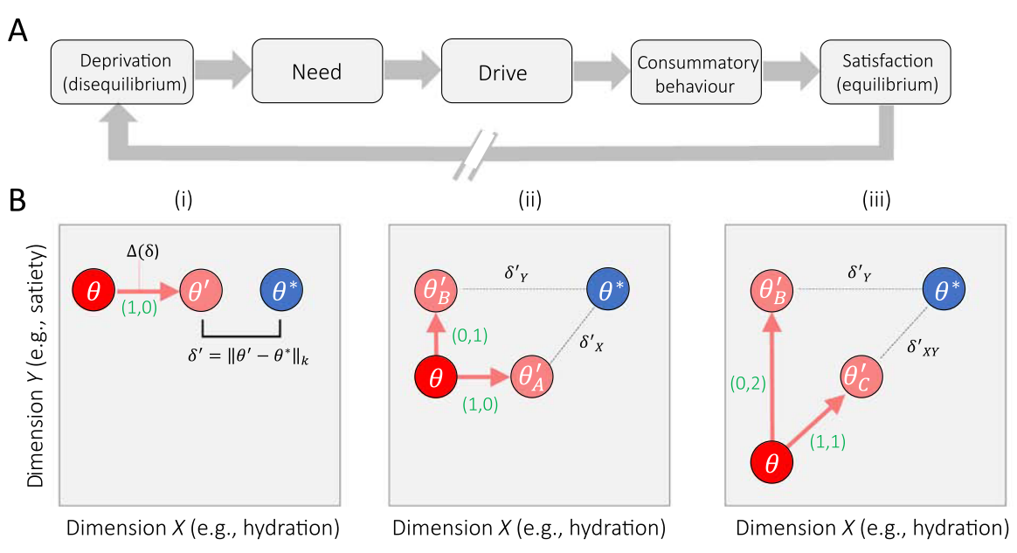
Figure a2.2

Appendix 1.3 – The Wider Primate Reward Circuit
In the introduction to this thesis we provide a brief history of the development of the idea that a representation of utility can be found in the dopaminergic neurons of the midbrain. We focus solely on this subcircuit (and restrict the supporting evidence to rodents, primates, and human studies) in the introduction for the sake of brevity, and because the neuronal data presented in chapter 4 of this thesis is recorded from these projections. However, economic decisions are universal and complex; it would be outrageous to suggest that such a small population of neurons represent the whole of the neuronal reward circuit. In this appendix we consider other brain regions of interest to researchers searching for neuronal correlates of reward, focusing on the cortical-basal ganglia circuit.
The Prefrontal Cortices and Reward
During the early 1990s, Edmund Rolls showed that single neurons in the orbitofrontal cortex (OFC) of macaques responded to flavour (Rolls et al., 1990) and that, crucially for reward encoding, these responses depended on the satiation of the animal in question (Rolls et al., 1989). O’Doherty et al., 2001 replicated this finding in human studies using functional magnetic resonance imaging (fMRI), showing separate regions on the orbitofrontal cortex in humans showed blood-oxygen-level-dependent (BOLD) activity mediated by pleasant and aversive taste stimuli which was expanded upon by Anderson et al., 2003 who showed that the OFC fMRI activity was associated with an increase in the valence, but not the intensity, of an odour stimulus.
In two later fMRI studies of humans performing monetary tasks, Brian Knutson showed that the medial prefrontal cortex (mPFC) shows an increase in BOLD signal upon the receipt of an award, but a decrease upon an expected monetary reward that is withheld (Knutson et al., 2003, 2005). Moreover, the BOLD signal incorporated both the magnitude and probability of the monetary rewards, and thus seemed to be computing the expected value on an economic stimulus (see equation 1.1; Knutson et al., 2005). That single cells in these prefrontal cortices encode economic value was later shown by Padoa-Schioppa & Assad, 2006 in a task where macaques made choices between amounts of liquid rewards. This study also dissociated the different activity of different single neurons, showing that some responded to the ‘offer value’ (how much juice or water was offered on a trial), whereas other responded to the ‘chosen value’ (the amount of the chosen liquid that had higher utility and was picked by the animal). This multiplexing of value signal including magnitude, probability and cost was replicated in the macaque prefrontal cortices by Kennerley et al., 2009.
In a similar task in which macaques had to choose between two pictures representing a magnitude of a juice reward, neuronal ensemble recordings from the OFC could be decoded to show the oscillation of value encoding between the two choice offers with response times on a single trial correlating with the time spent by the ensemble in the ‘unchosen state’ (Rich & Wallis, 2016). Furthermore, low current (25-50μA stimulation of macaque OFC cells was sufficient to bias choices in a similar task, whereas high current (≥100μA) did not bias choices but did increase the variability of choices (Ballesta et al., 2020).
The rich, heterogeneous responses of frontal lobe neurons to tasks was interesting to us and we strongly considered recording from this region when developing the project due to the increased sophistication of the BDM when compared to traditional choice paradigms. For example, instead of choosing discretely between two offers, a monkey must instead choose between continuous values of a bid. As a monkey then makes their choice, they pass through the other choices which must be continually considered and find an optimal stopping value to place their bid at.
The Amygdala and Reward
Many of the pioneering human fMRI studies discussed in the last section also found significant changes in the BOLD signal in the human amygdala during economic value tasks (Breiter et al., 2001; O’Doherty et al., 2001). The amygdala are a collection of nuclei located in the medial temporal lobe of mammals most commonly implicated in fear processing (LeDoux, 2007). Once the amygdala was implicated in economic decisions, studies found this fear processing could be extended to uncertainty of a potential loss (Hsu et al., 2005; Kahn et al., 2002), an idea extended by findings that humans with bilateral amygdala lesions show markedly reduced loss aversion (see appendix 1.1 for a discussion of Prospect theory; De Martino et al., 2009).
As with the prefrontal cortices, single cell recordings from non-human primates have supported the idea that neurons in the amygdala encode economic value. Bermudez & Schultz, 2010 used a Pavlovian task where the display of a stimuli predicted a juice reward with three possible magnitudes finding that the activity of a population of amygdala neurons increased their activity after the delivery of the juice, and that one third of these had changes in activity that correlated with the magnitude of the juice received. In a replication of Padoa-Schioppa & Assad, 2006, Jezzini & Padoa-Schioppa, 2020 found that basolateral amygdala (BLA) neurons also showed heterogenous responses in a choice task, though with many more neurons coding the chosen value than in the OFC.
In appendix 1.2, we discuss the idea that value arises from progress towards a goal (Juechems & Summerfield, 2019). Interestingly, studies of humans and macaques have implicated the amygdala in progression to some internal stopping point on a ‘spend-save’ task (Grabenhorst et al., 2016; Zangemeister et al., 2016). Both humans and monkeys could choose to either ‘save’ (and accumulate liquid rewards with interest) over trials or ‘spend’ (and consume the saved liquid). In humans, BOLD activation in the amygdala encoded the length and value of save sequences and single BLA neurons in macaques showed ramping phasic activity as a sequence of save trials progressed towards the monkey’s choice to consume their reward.
Perhaps most intriguing for studies involving auction theory is that the amygdala seems to be involved in processing economic and social stimuli (see Rutishauser et al., 2015 for a review). In appendix 1.1 we discuss the ‘winner’s curse’ in auction theory- the idea that on auction the winner is likely to have overpaid for a good (Capen, E. C. Clapp, 1973). The auctions presented in this thesis use a random computer bid as is typical for the BDM paradigm, however, it is possible to imagine future studies which involve multiple organisms bidding to receive one reward per trial. BLA neurons have been shown to respond to the value of rewards for oneself and to those given to another monkey in a donation game, but not to rewards donated by a computer (termed ‘value-mirroring’ neurons by the authors; Chang et al., 2015). Moreover, in a learning task, amygdala neurons track value learnt from a primates own choices as well as those made by another monkey in view (Grabenhorst et al., 2019). These neurons are then able to simulate the choices made by a different animal, a strikingly similar paradigm to how humans can optimally bid on auctions by simulating the discounting of other actor’s bids (Wilson, 1967).
Other Structures Implicated in the Reward Circuit
We focus on the prefrontal cortices and amygdala here as we find the evidence for value encoding in these areas the most striking. The entire reward circuitry of primates is known to be more complex (Haber & Knutson, 2010) and involves the striatum (Samejima et al., 2005; Strait et al., 2015), lateral habenula (Matsumoto & Hikosaka, 2009), anterior cingulate cortex (Azab & Hayden, 2018), and lateral hypothalamus (Harris et al., 2005) amongst others.
Dopamine neurons from the ventral tegmental area (VTA) or the substantia nigra pars compacta (SNc) provide input to most of these implicated areas via the mesolimbic-mesocortical and nigrostriatal projections (figure 1) and are hypothesised to form a ‘reward retina’ conveying a signal of how a reward deviates from expectation to downstream regions of the brain which integrate additional information (Wolfram Schultz, 2009). These two populations receive distinct inputs from a wide range brain areas, with the dopaminergic neurons of the VTA receiving most input back from the ventral striatum and lateral orbitofrontal cortex, as well as inhibitory input from the lateral habenula (Matsumoto & Hikosaka, 2009). By contrast, the SNc receives most of its input from the somatosensory and motor cortices, as well as the subthalamic nucleus, the dorsal striatum and nucleus accumbens (Watabe-Uchida et al., 2012).

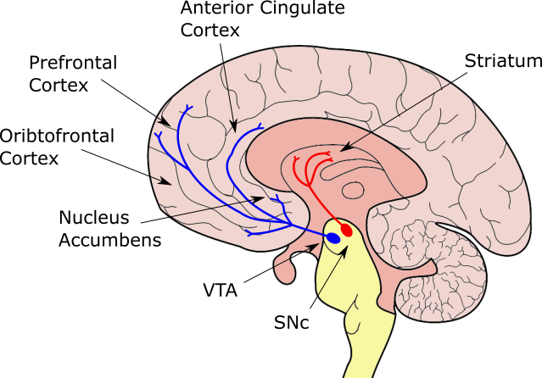
Figure 1) The dopaminergic pathways of the ventral tegmental area (VTA) and substantia nigra pars compacta (SNc) project to most regions implicated in economic decision making. Dopaminergic nuclei located in the midbrain have wide ranging projections. The nigrostriatal projections from the substantia nigra pars compacta reach to the striatum (red). The mesolimbic-mesocortical projections originate in the ventral tegmental area are reach to the prefrontal cortices as well as the nucleus accumbens and the anterior cingulate cortex.

Neither literally how neurons calculate and compare utilities, nor philosophically how a 1500g piece of meat manages to hold its own against intelligently designed computer programs. As an essay beloved by the author puts it (Bisson, 1990): "We probed [humans]. They're meat all the way through." "[They don’t have a brain?]" "Oh, there is a brain all right. It's just that the brain is made out of meat!" "So... what does the thinking?" "You're not understanding, are you? The brain does the thinking. The meat." "Thinking meat! You're asking me to believe in thinking meat!"
The examples used here are mostly to make a rhetorical point to introduce the idea of external unitary scales of decisions, and the lack thereof in economic decision-making. The point could well be made that all perceptual decisions are a subset of economic decisions. For a brief discussion on economic decision-making as psychophysics see appendix 1.1 and Luce, 1959.
Of course, this only considers value-in-use, rather value-in-exchange for the purposes of a simplified, illustrative example. We also skip over the idea that it is the marginal utility rather than the utility per se that causes the starving man to value food highly for the purposes of our point. See White, 2002 (check your non parenthesis citation style, I think it should parenthesise the year when used inline) for a critical take on this common economic fable which goes beyond the scope of this thesis.
A medieval unit of currency. 20 ducats would have been a substantial sum on the order of hundreds/thousands of dollars in today’s currency. A more recent recreation of the St Petersburg Paradox reveals that modern undergraduates place a median value on the game of $1.50 (Hayden & Platt, 2009) though this uses a modified version where a participant wins $$2^{n-1}$ i.e. half what they would win in the version presented here.
In modern terminology the concavity of the utility function forms Gossen’s First Law, also known as the ‘law of diminishing marginal utility’, described by the 19th century economist (Gossen, 1983).
Sometimes von Neumann-Morgenstern expected utility is differentiated from this equation as $${EU}_{i,n}= p(x_{n})⋅{U_{i}(x}_{n})$$ For the purposes of this thesis, we consider the differences unimportant.
Throughout this thesis we refer to experimental paradigms where a subject indicates a choice between two goods, or bundles, as a ‘binary choice task’. 3 such binary choices are illustrated in figure 1a-c). This is compared in chapter 2 to an auction task in which a subject indicates a value they would be willing to pay for a good/bundle in terms of another other good.
Especially in the ICS literature it is difficult to anthropomorphise the rats as receiving ‘pleasure’ from the self-stimulation. Even when studying physiological markers which correlate with pleasure in humans, it is not clear to us that any model organism necessarily has a positive emotional valence associated with their choices/behaviour in neuroeconomic studies. Throughout this chapter we use words such as ‘pleasure’ and ‘reward’ while detailing the progression of neuroscience into economic decision-making, building up to studies which instead correlate neuronal activity with the more formal, neutral, term ‘utility’. Throughout the rest of the thesis we ascribe an animal’s motivations to maximising this neutral quantity of utility. For a brief review of ‘wanting’ vs ‘liking’ motivations in organisms making behavioural choices, see appendix 1.2.
For a colloquial explanation of the signal: dopamine neurons typically have a tonic firing rate of ~5Hz (imagine a fast bass drum beat). For a view of what 'firing' means see Figure 4.1 showing the average trace of a 'spike' from a representative dopaminergic neuron we recorded in this project. Upon delivery of an unexpected reward midbrain dopamine neurons produce a very brief 'drumroll' of the same spikes with a much shorter latency between. The increase in firing rate described happens within this 'drumroll' before the neuron returns to its 'resting' tonic frequency.
'Aversive' stimuli can create an initial positive increase in dopaminergic firing rate thought to be mediated by a 'saliency' signal (Schultz, 2016). This saliency signalling of dopaminergic neurons occurs earlier (within the first 120ms of stimulus presentation) and is correlated with the perceptual intensity of the stimulus (e.g. brightness, loudness), the novelty of the stimulus (though novelty alone is not sufficient to generate it; Tobler et al., 2005), and whether it shares characteristics (e.g. modality) of other conditioned stimuli for rewards (Day et al., 2007).
A simplification. Dopamine release is not a simple linear function of dopaminergic cell firing rate (Mohebi et al., 2019). Indeed, dopamine release may not even fully necessitate anything upstream of the dopaminergic varicosities as cholinergic stimulation in the striatum seems to be able to shunt release of dopamine (Mohebi & Berke, 2020).
This thesis was written in the autumn of 2020; the implications for taking findings from behavioural economics seriously should be obvious.
We consider that behavioural/experimental/neuroeconomics is still in its infancy and if we ever do find a Grand Unified Microeconomic Theory it will not be for many years (Noone will ever need more than 640kb of Ram)
Amos Tversky died in 1996
We only consider situations in which organisms choose between 2 options here for brevity. Of course, these tasks can be extended to choices between as many alternatives as an experimenter sees fit. Indeed, these might better capture the ethological choices made by organisms.
A simple game of this type can be modelled with two suitors where the 'winner' of the more beautiful bride offered has to pay the second price to the loser (second prices pop up in the most unexpected places!). This auction paradigm can be shown (Baye et al., 2012) to lead to similar results as Bhattacharyya & Lipman, 1995 that traders who know they are following symmetric strategies might both have a positive expected value of their mixed strategy even as they understand that only one of them can actually make a profit on a trade. Because trades and bridal prices are unbounded, each player's expected utility is not integrable with respect to the joint distribution of possible mixed strategies, and no Nash equilibrium can be found.
The second Caesar of the 'Year of Five Emperors' (not to be confused with the 'Year of Four Emperors' [69AD], nor the 'Year of the Six Emperors' [238AD]).
The Bank of England only began gilt auctions in 1987 (“The Gilt-Edged Market : Auctions,” 1987).
Bazerman and Samuelson empirically tested this winner’s curse in first price auctions, getting MBA graduate students to bet on the value of a jar filled with nickels. On average, winning bids are roughly 25% greater than the value of the coins being bid for (Bazerman & Samuelson, 1983).
As with much of microeconomics, this finding has a few assumptions which can be violated. Maskin and Riley showed that theoretically this ordinal ranking of auction mechanisms can be reversed if bidders are risk-averse (Maskin & Riley, 1984).
In one particularly famous case, a group of dentists won the rights to spectrum in Cape Cod, Masachussettes which they then sold onto Southwestern Bell Telecommunications for $41million profit (McMillan, 2009).
This framing in this thesis of most, if not all, of conscious human behaviour as making economic choices is partly done for hyperbole and may be contentious, but is not in itself wrong. ‘Economic imperialism’ has regularly claimed all purposeful (human) behaviour as under the field of economics (see Stigler, 1984). If all behaviour is economic, we find it amusing to wonder why so little is written on the ‘psychological/ethological imperialism’ of the minds that perform these choices, or even a ‘neuroscientific imperialism’ of the brain which must surely create those minds (for a more thorough and considerate discussion of the idea see Bujold, 2019).
Throughout the main text of the thesis, we try to only refer to ‘utility’ as the quantity maximised by our monkey’s making economic choices. Here we break from that somewhat and talk about ‘value’ to fit with the literature we will be discussing, and also because we want to use this appendix to digress and discuss the ideal of ‘value’ rather than observed measurements of ‘utility’
Though we prefer a simpler statement misquoted from a Clint Black song: “[value] isn’t something [an object] has; it’s something that we do”.
For a more recent review of the idea and criticism that goes beyond this appendix, see Berridge & O’Doherty, 2013.
This section is predominantly guided by the Juechems & Summerfield paper, in turn built upon a human fMRI paper which focus on the cortex. See Bogacz, 2020 for an interpretation of dopaminergic neurons in this context.
An example chosen as recent work has extended this ‘efficient coding hypothesis’ into the domain of experiments studying the behaviour of participants in an economic decision making setting (Polanía et al., 2019).
For the sake of argument, ignoring altruistic sacrifices but we can also assume these are done to pass on similar genes in the beneficiary population.
Obviously an anthropomorphism.
For the sake of brevity this argument ignores the evidence
Two caveats. Firstly, the mechanisms by which value is learnt in conditioning is not necessarily the same as how values are compared in economic choice behaviour. Secondly, it is rivalled by progress understanding episodic memory consolidation and retrieval in the mammalian hippocampus. See Tonegawa et al., 2015 for a review and Lisman, 2016 for a discussion of both of these systems within the context of Marr’s three levels.
There is evidence for dopamine’s role in guiding reinforcement in fruit flies (Waddell, 2013) and sea slugs (Reyes et al., 2005) though these are unlikely to be true homologues of the primate reward system. Instead, it is probably likely that conserved dopaminergic systems represent a path of least resistance for the evolution of reward circuits (Barron et al., 2010).
We refer to both the medial prefrontal cortex (mPFC) and orbitofrontal cortex (OFC) as prefrontal cortices in this appendix despite these being anatomically distinct regions. We touch upon why different studies might find activation of one or the other when discussing the replication of BOLD signal activity correlation with bid in human experiments using the BDM and so will not here. A brief discussion can also be found in Padoa-Schioppa & Conen, 2017.
Though changes in BOLD signal have been found in both these regions during the same task, it is a simplification to conflate the roles of both these regions as we do to some extent here. Both macaque fMRI and single cell electrophysiology studies have found subtle differences in the neuronal activity of the prefrontal cortices and amygdala in Pavlovian (Saez et al., 2017) and credit-assignment (Chau et al., 2015) tasks.

